Lab Exercise - Configure ClusterIP Service in AKS using Azure Cloud Shell

Objective
In this lab, you will:
- Create an AKS cluster
- Deploy an NGINX application
- Create a ClusterIP Service
- Verify internal communication between pods
- Test service discovery inside Kubernetes
using Microsoft Azure Kubernetes Service (AKS).

What is ClusterIP Service?
ClusterIP is the default Kubernetes Service type.
It provides:
- Internal communication inside Kubernetes cluster
- Internal IP address
- Pod-to-pod communication
ClusterIP services are NOT accessible from the internet.

Architecture
Client Pod
|
ClusterIP Service
|
NGINX Pods
|
AKS Cluster

Concepts Covered
- AKS
- Kubernetes Deployment
- Kubernetes Services
- ClusterIP Service
- Internal Networking
- Service Discovery
- Pod Communication

Prerequisites
- Azure Subscription
- Azure Cloud Shell access

Lab Configuration
Resource | Value
Resource Group | rg-clusterip-lab
AKS Cluster | aks-clusterip
Node Count | 1
VM Size | Standard_B2s
Node Pool | agentpool
Region | centralindia

Step 1: Open Azure Cloud Shell
Open:
Azure Portal
Launch:
- Cloud Shell
- Bash

Step 2: Create Resource Group
az group create \
--name rg-clusterip-lab \
--location centralindia

Step 3: Create AKS Cluster
This command follows lab policy restrictions.
az aks create \
--resource-group rg-clusterip-lab \
--name aks-clusterip \
--node-count 1 \
--node-vm-size Standard_B2s \
--nodepool-name agentpool \
--generate-ssh-keys

Wait 5–10 minutes.

Step 4: Connect to AKS Cluster
az aks get-credentials \
--resource-group rg-clusterip-lab \
--name aks-clusterip

Step 5: Verify Cluster
kubectl get nodes

Expected:
STATUS = Ready

Step 6: Create NGINX Deployment
kubectl create deployment nginx-app \
--image=nginx

Step 7: Verify Deployment
kubectl get deployments

Step 8: Verify Pods
kubectl get pods

Expected:
Running

Step 9: Create ClusterIP Service
kubectl expose deployment nginx-app \
--port=80 \
--target-port=80 \
--type=ClusterIP \
--name=nginx-clusterip

Step 10: Verify Service
kubectl get svc

Expected:
TYPE = ClusterIP
You will also see:
- Internal Cluster IP
- Port number
Example:
nginx-clusterip ClusterIP 10.x.x.x

Step 11: Describe Service
kubectl describe svc nginx-clusterip

This shows:
- Cluster IP
- Endpoints
- Port mappings
- Target pods

Step 12: Test Internal Connectivity using BusyBox Pod
Create temporary client pod:
kubectl run test-client \
--image=busybox \
--restart=Never \
-- sleep 3600

Step 13: Verify Client Pod
kubectl get pods

Expected:
- test-client
- Running

Step 14: Access Client Pod Shell
kubectl exec -it test-client -- sh

Step 15: Test DNS Resolution
Inside pod:
nslookup nginx-clusterip

Expected:
- ClusterIP address returned
Example:
Name: nginx-clusterip
Address: 10.x.x.x

Step 16: Test HTTP Connectivity
Inside pod:
wget -qO- http://nginx-clusterip

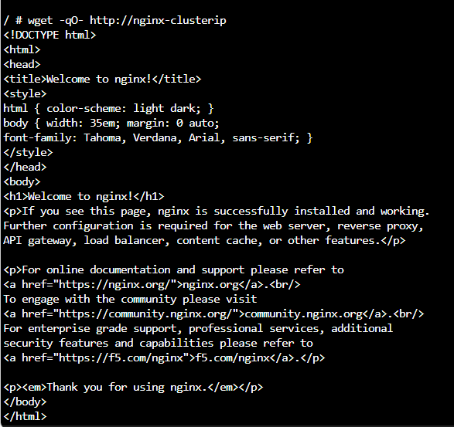
Expected:
- NGINX HTML page output
This proves:
- ClusterIP service works internally
- Pods communicate successfully

Step 17: Exit Client Pod
exit

Step 18: Scale NGINX Deployment
kubectl scale deployment nginx-app \
--replicas=3

Step 19: Verify Scaling
kubectl get pods

Expected:
- 3 NGINX pods running

Step 20: Verify Service Endpoints
kubectl describe svc nginx-clusterip

You should see:
- Multiple pod endpoints
This demonstrates:
- Load balancing through ClusterIP

Step 21: Test Connectivity Again
Access test-client:
kubectl exec -it test-client – sh

Run:
wget -qO- http://nginx-clusterip

Service still works despite multiple pods.

Step 22: Delete Test Client Pod
kubectl delete pod test-client

Step 23: Delete ClusterIP Service
kubectl delete svc nginx-clusterip

Step 24: Delete Deployment
kubectl delete deployment nginx-app

Step 25: Verify Cleanup
kubectl get all

Step 26: Delete AKS Cluster (Optional)
az aks delete \
--resource-group rg-clusterip-lab \
--name aks-clusterip \
--yes

Step 27: Delete Resource Group (Optional)
az group delete \
--name rg-clusterip-lab \
--yes

Expected Outcome
After completing this lab:
- AKS cluster deployed
- NGINX application deployed
- ClusterIP Service created
- Internal pod communication verified
- DNS resolution tested
- Internal load balancing demonstrated

